**Transit Gateway**

Transit gateway is a services that allow you can interconnect your vpc’s on-premise network to a center hub.

**Step 1:**

Now we will create a transit gateway.

First we need to create three vpc’s

* Creation of vpc,subnets,route table,internet gateway by vpc and more option.

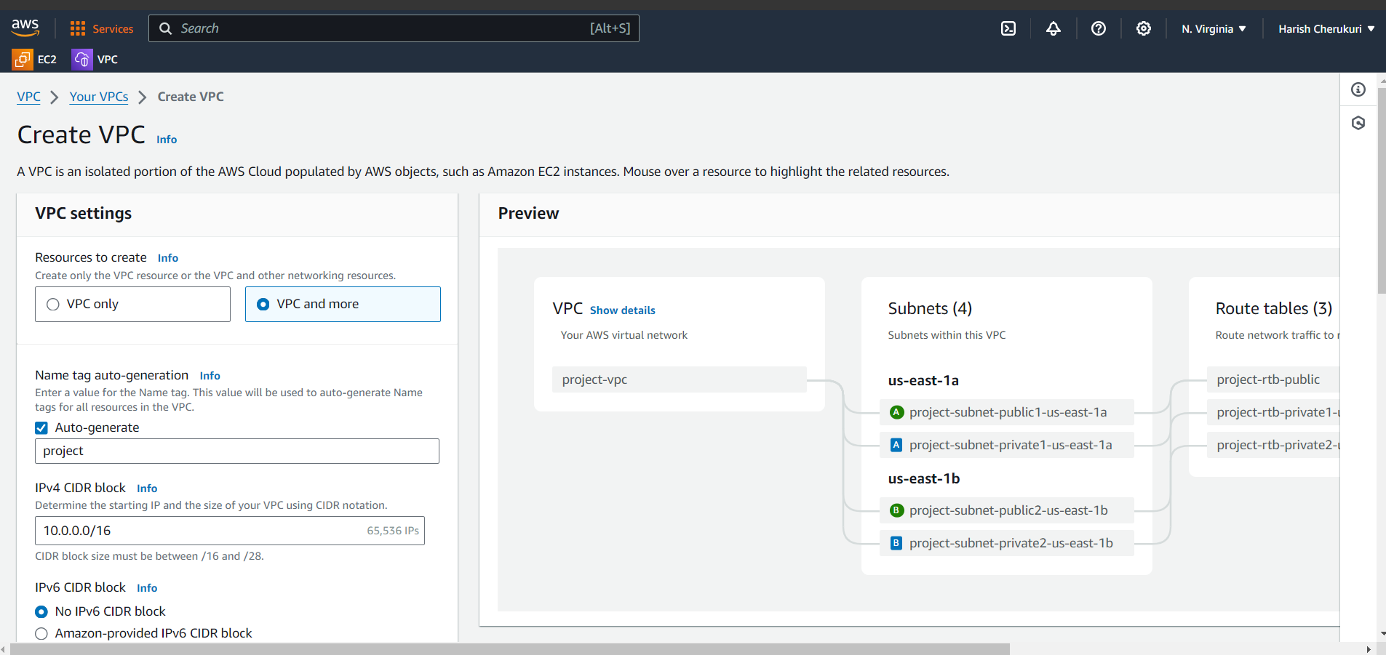

* Give the vpc name as tg-1
* Give the cidr block as 10.0.0.0/16 this cidr gives the ip addresses
* Click no ipv6

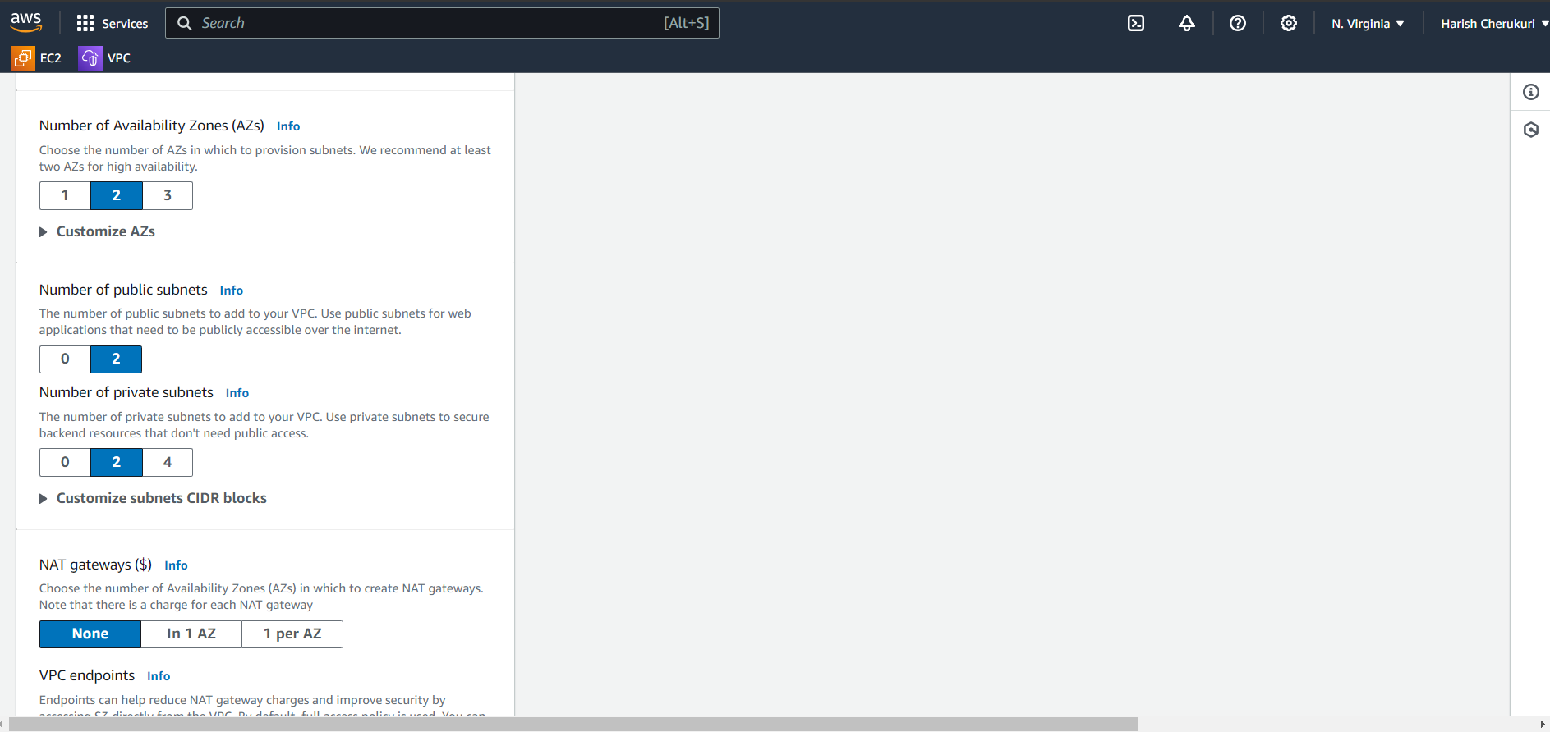

* Select the number of availability zones
* Select the number of public,private subnets.
* After selecting the click on create vpc.

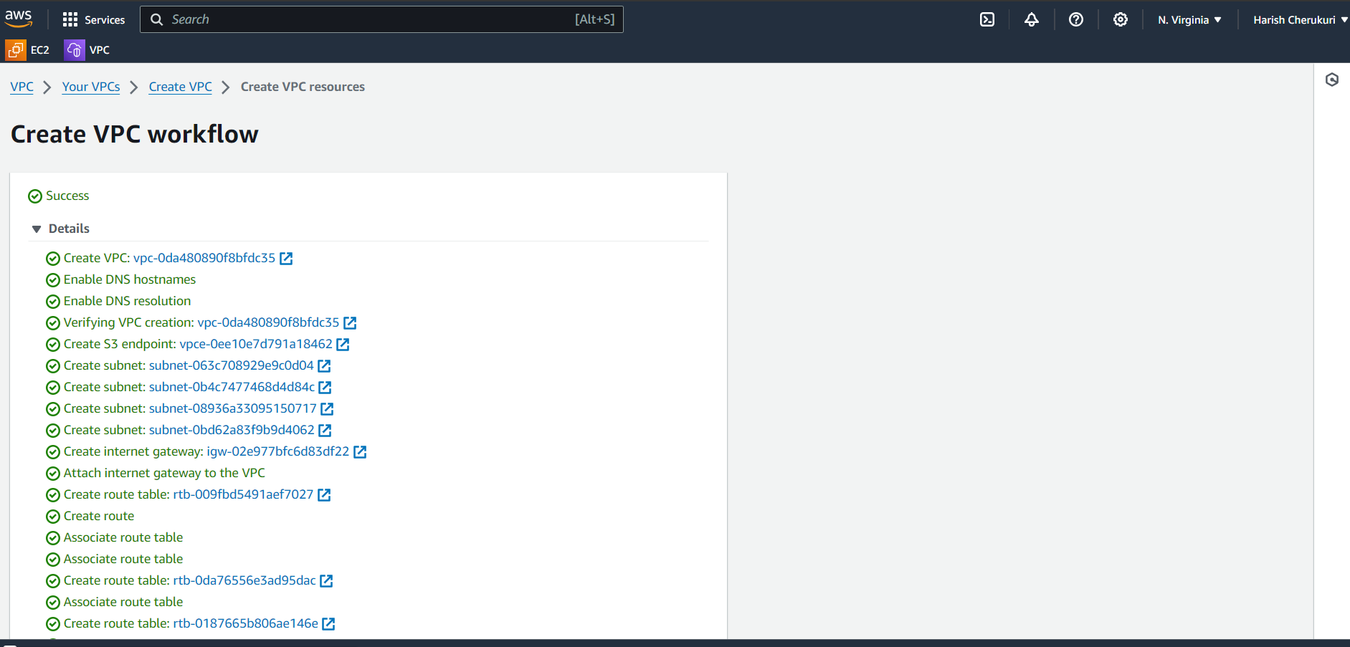

It will create like this automatic.

Like that create remaining two vpc’s.

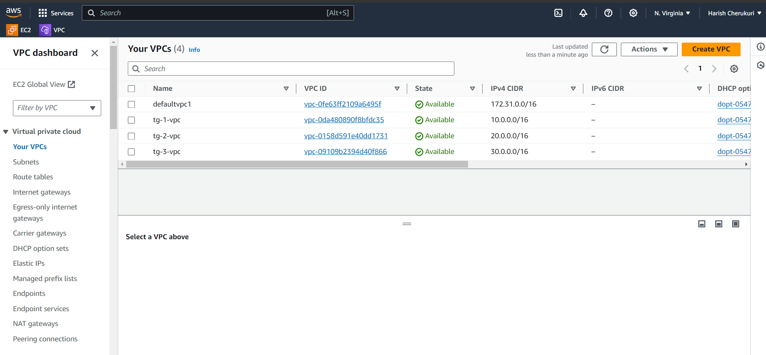

Your three vpc’s are created with different cidr block numbers.

**Step 2:**

Now create the transit gateway.

Relocate to transit gateway and click on create transit gateway.

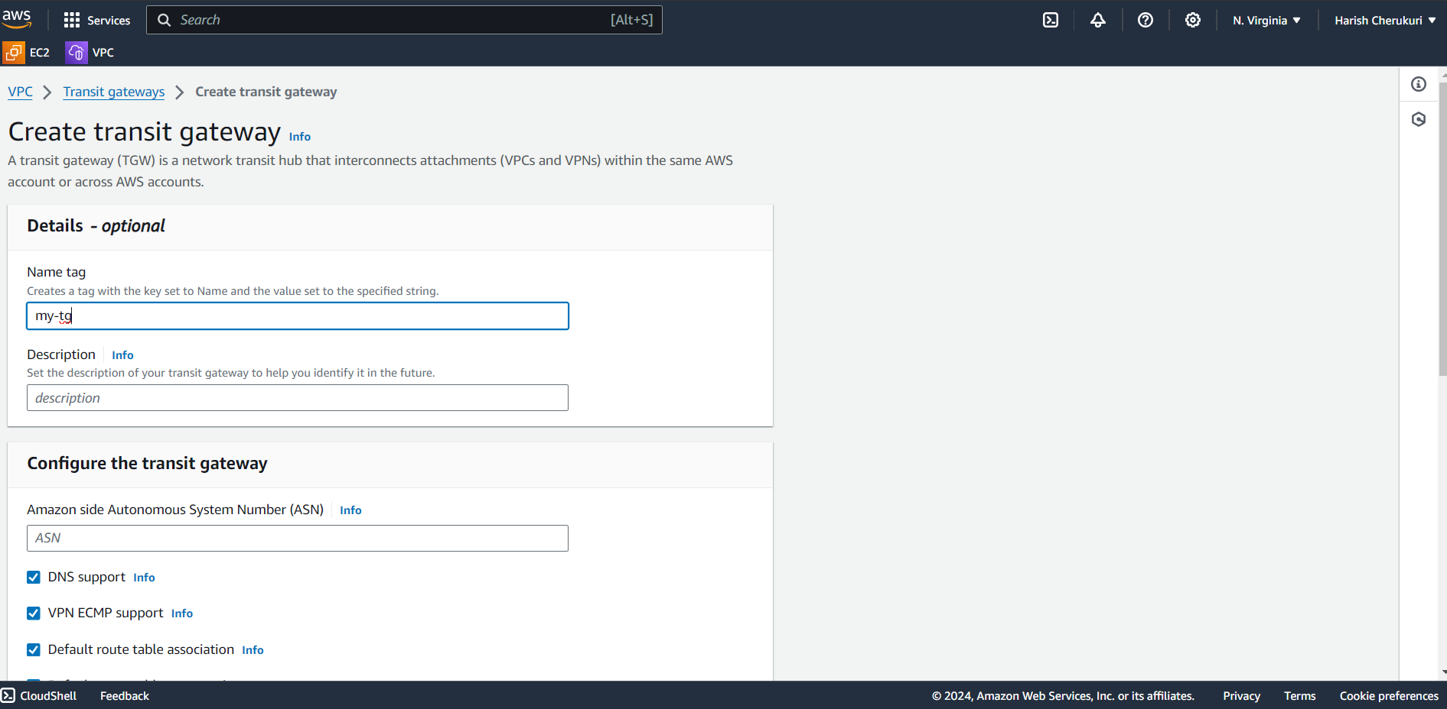

Give the transit gateway name and click on create transit gateway.

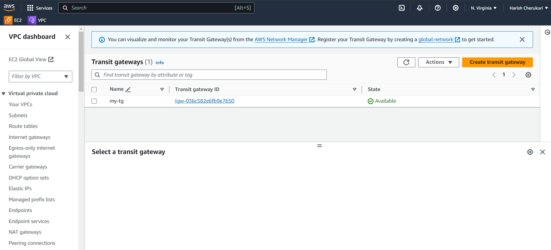

The transit gateway is created.

Now its time to attach the three vpc’s to transit gateway.

Under the transit gateway service transit gateway attachment is there click on create transit gateway attachment.

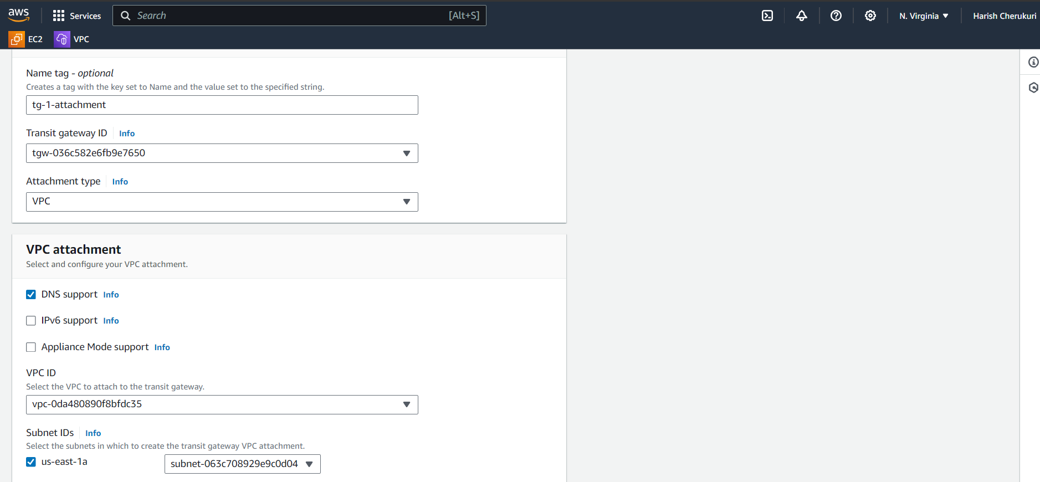

Give the attachment name.

Select the transit gateway id and attachment type.

Select the first vpc id it will show the which subnets are present in selected vpc.

Like this attach remaining two vpc’s also.

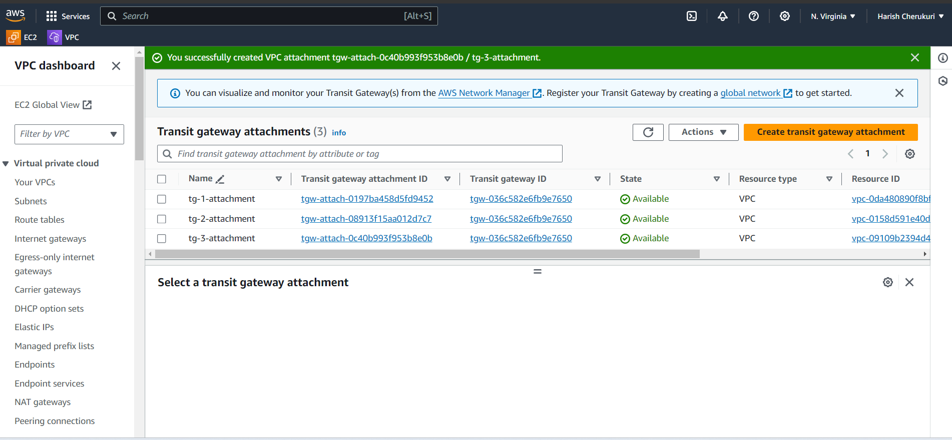

Remaining two vpc’s also attached.

Now go to every vpc’s route table and add routes.

If you enter to tg-1 vpc 10.0.0.0/16 this is source cidr block now add the remaining two vpc’s cidr block number in destination 20.0.0.0/16 and 30.0.0.0/16.

Now go to second vpc is tg-2 20.0.0.0/16 add 10.0.0.0/16 and 30.0.0.0/316 in destination.

Now go to last vpc of 30.0.0.0/16 add 10.0.0.0/16 abd 20.0.0.0/16 in destination.

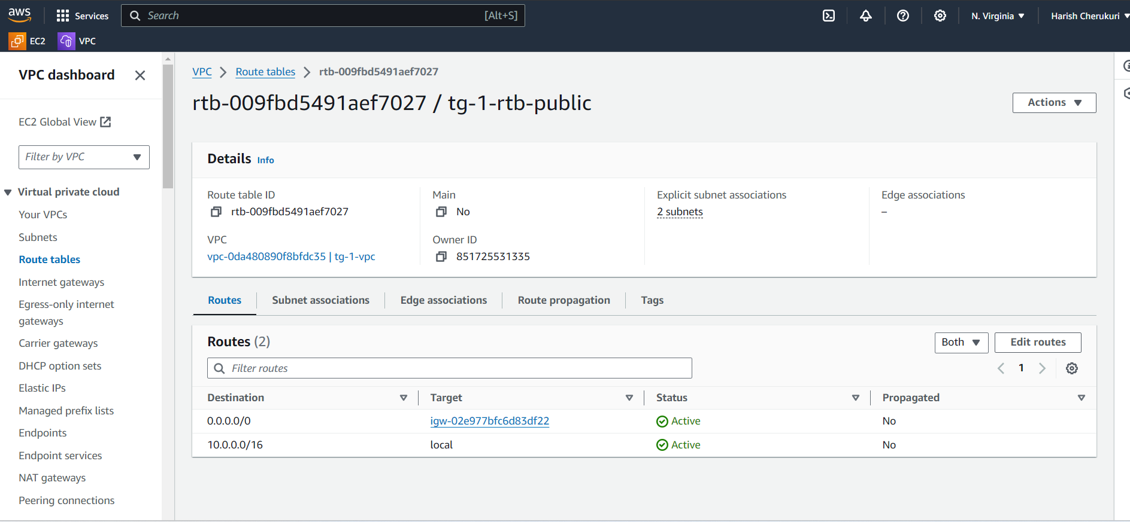

Click on action

Click on edit routes.

Add routes.

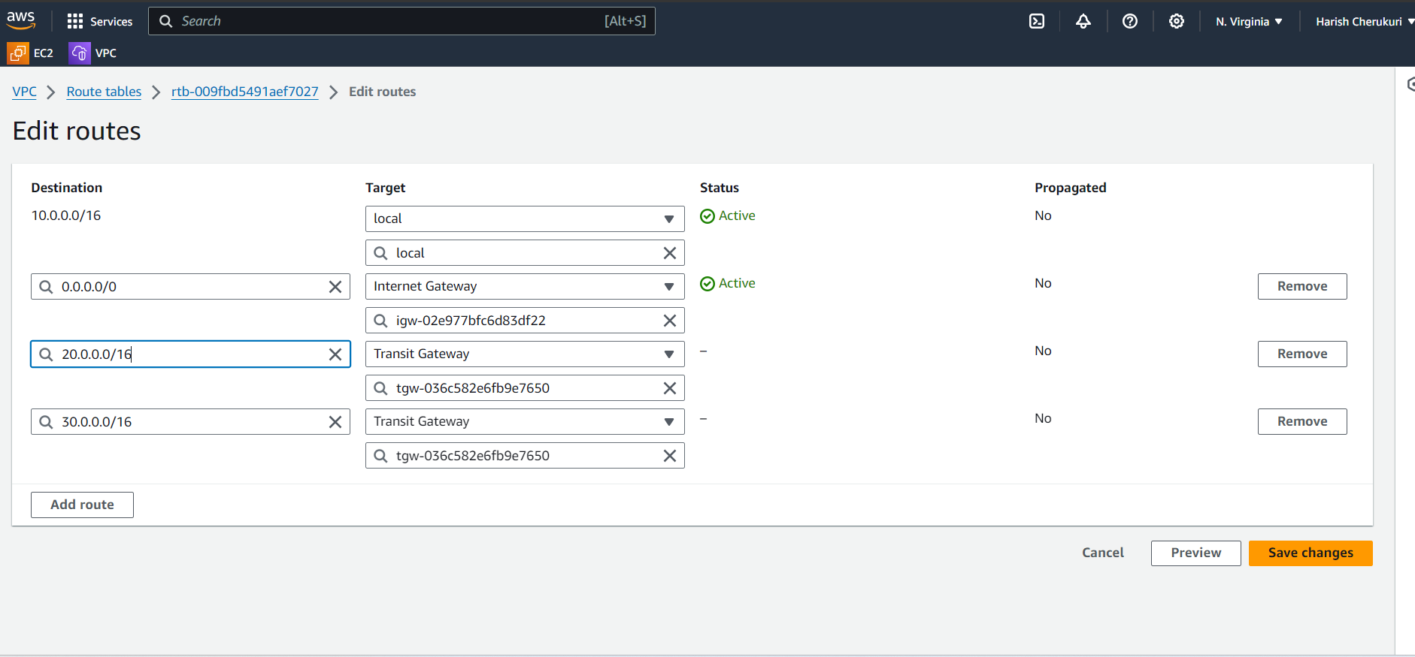

Add remaining two vpc’s cidr and target gateway.

Click on save changes.

Like this add routes to remaining two vpc’s routes.

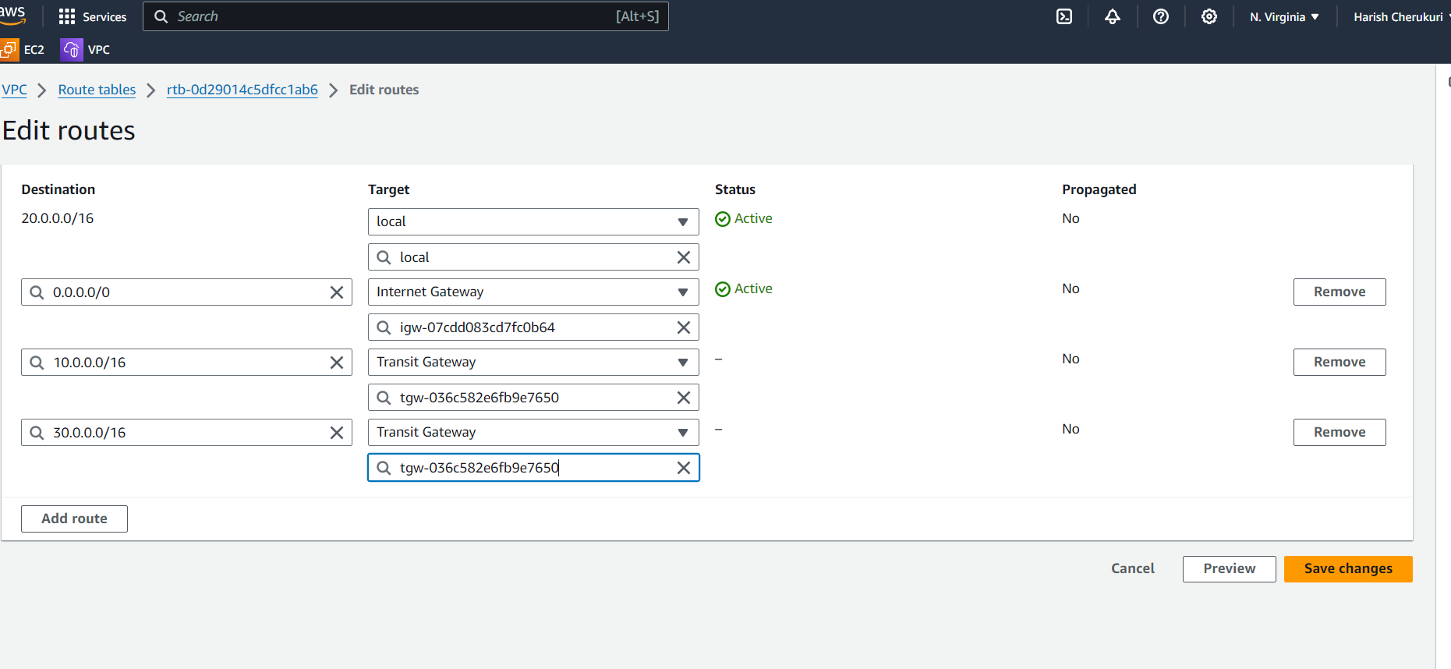

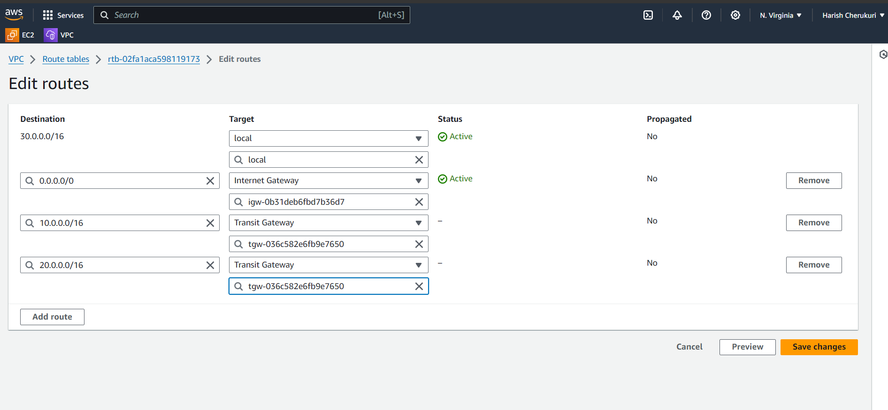

**Step 3:**

Now create the three ec2 instances for three vpc’s.

Launch instance

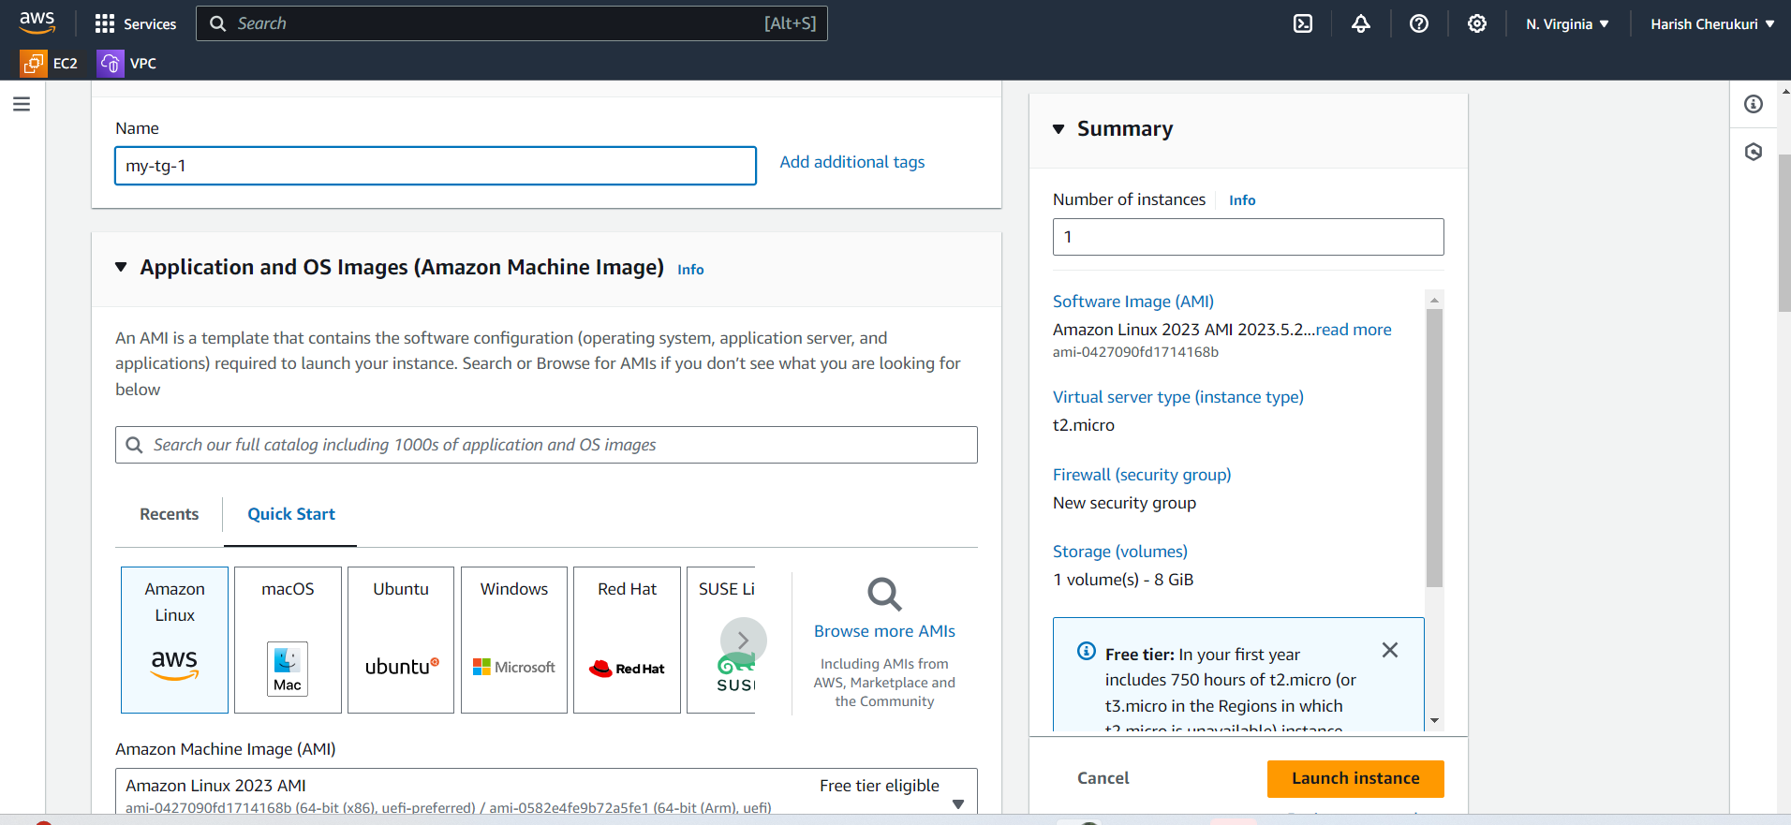

Give ec2 instance name as my-ec2-tg-1 and select amazon linux.

Select the kay pair.

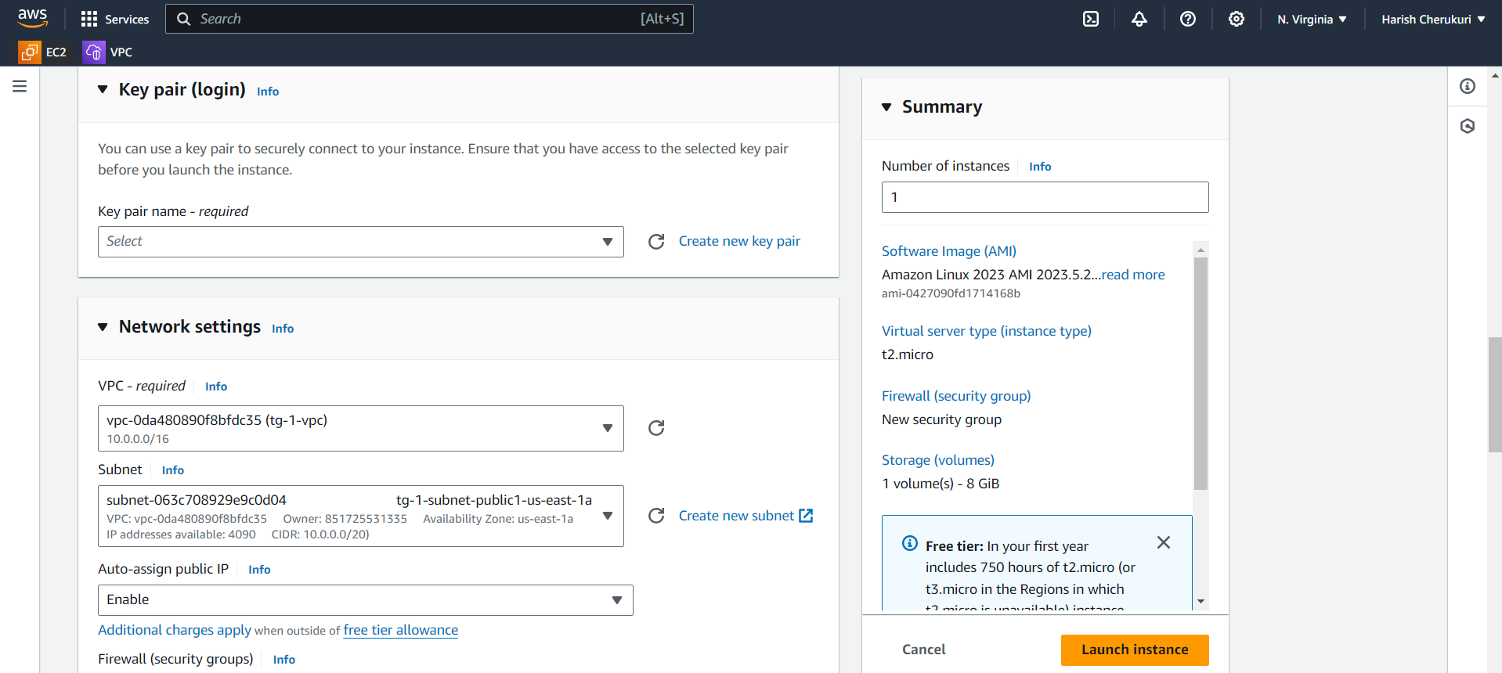

We createing ec2 for first vpc so select first and slecet the subnet click on enable in auto-assign public ip.

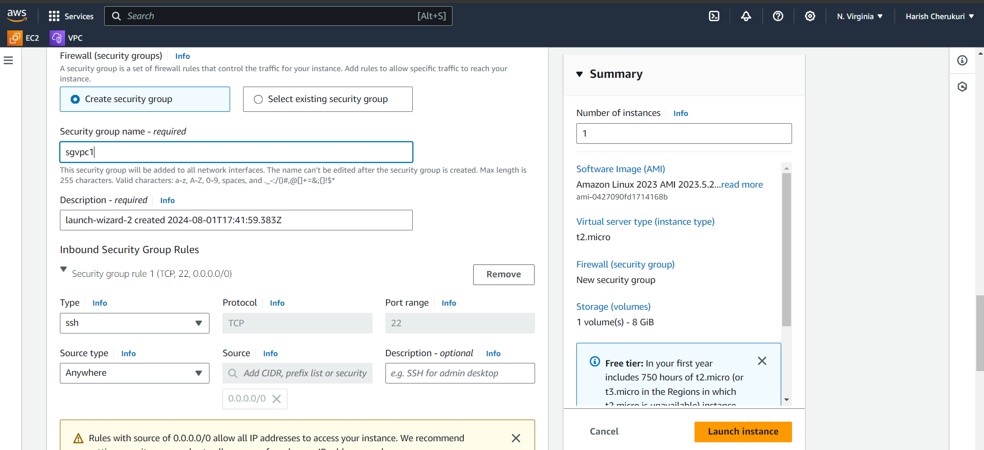

Create security group and launch instance.

After launching the instances connect to server using ssh.

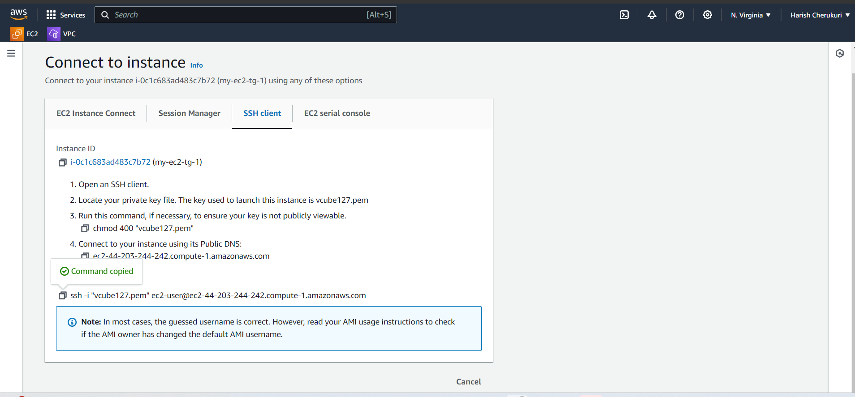

Copy the ssh paste it in git bash.

After connected to server.

Change to normal user to root user by sudo -i

Update and install nginx

Yum update -y && yum install nginx -y

Go to nginx path

Cd /usr/share/nginx/html

Give ls

It will show the file and directies available in that path

Remove the index.html

Create new file using vi editor.

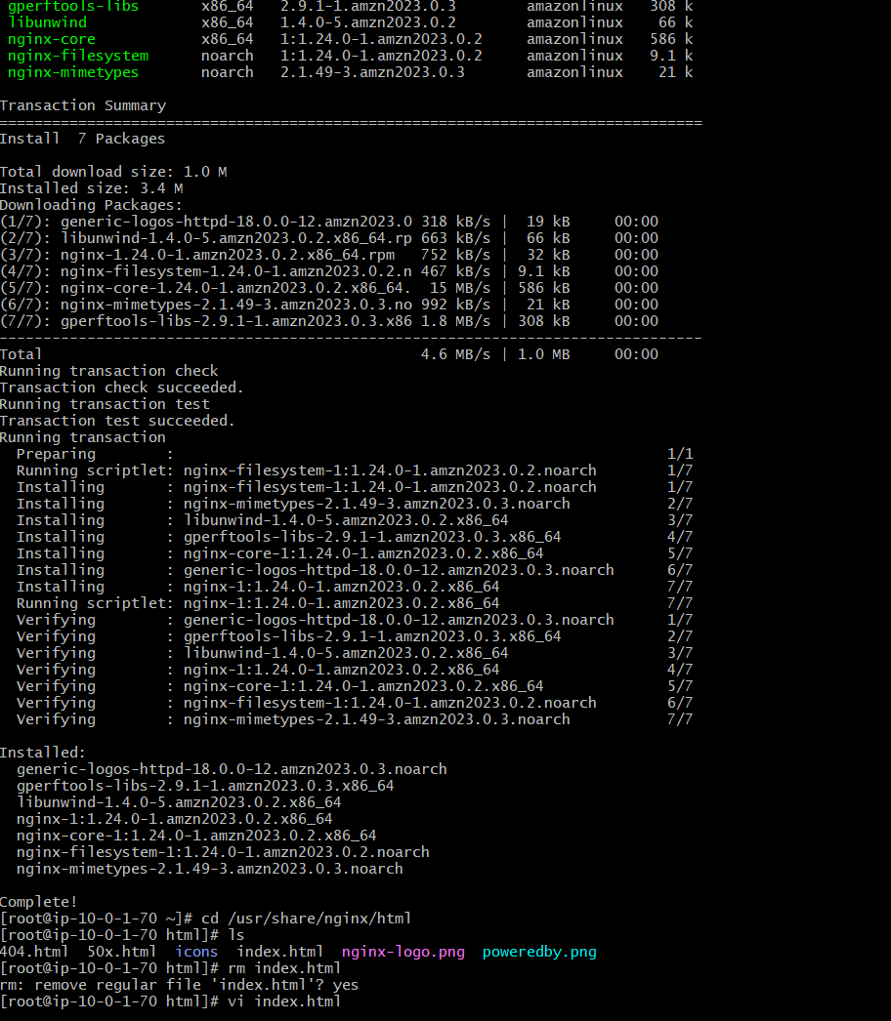

You will enter into the vi editor add some data in it using insert mood.

After enter the data save and come out by using “wq1”.

Now gice curl 10.01.70

It will show what data inside the file.

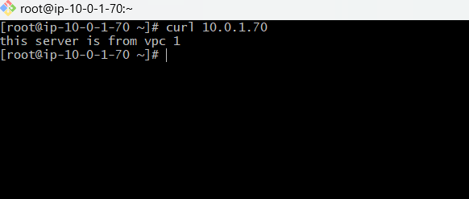

Like this create remaining two ec2 instances and add data to it.

After creation all instances

Give curl ip address of other vpc’s

Now you are in instance 1 give

Curl 20.0.4.41 of second server ip address.

It will show the what data inside the 2 server .

Like that

Curl 30.0.12.59 of third server ip

It show the what data inside the 3rd server.

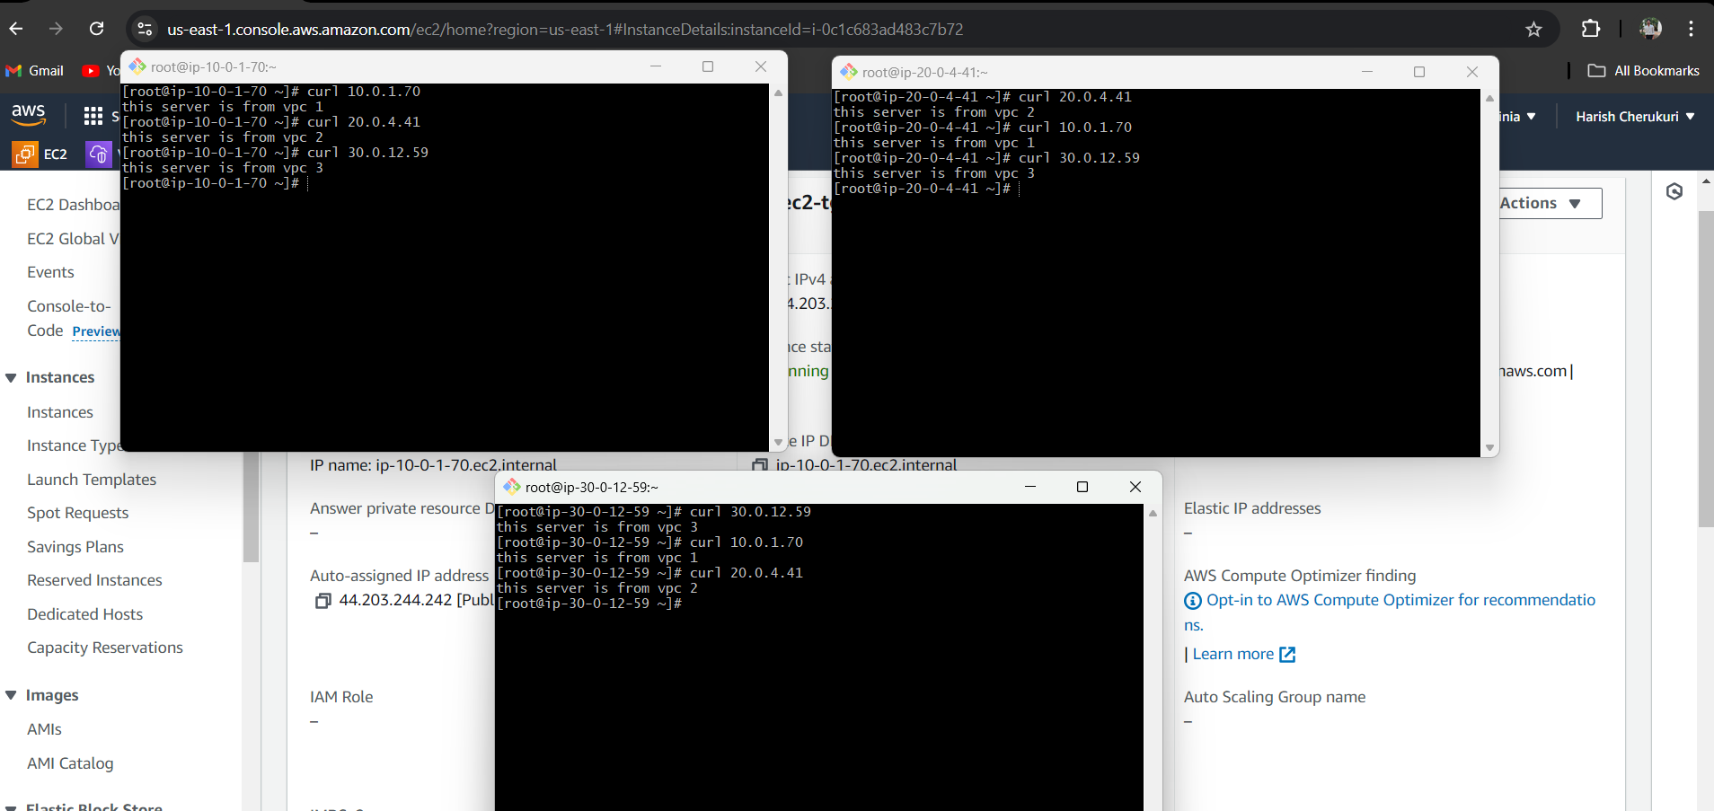

**Conculsion**

Therefore, using transit gateway the three vpc’s network are interconnected to share the data in it from vpc to other vpc.

